Git Assignment:

Exercise 2

Exercise 3

Exercise 4:

Exercise 5:

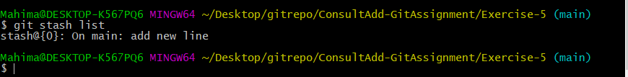

Exercise 6:

Exercise-7

Exercise -8:

Exercise -9

